**L&T project**

**Title:**

Automated Dustbin system

**Problem statement:**

Develop a simple Ardunio UNO-based Automatic dust Bin system which can open the lid when it senses the object movement nearby.

**Scope of the solution:**

The core objective of the **Arduino Smart Dustbin** is to detect the presence and open the dustbin, later after the trash is put we have to close it. In a previous project , we used a Ultrasonic sensor that could spot objects, and when it did, the robot changed its route to follow the object (our human). In our **Smart Dustbin Arduino project**, we there doing something similar. We have put Ultrasonic sensor on top of the dustbin's cover. So, when the sensor sees something like a person's hand, it tells the Arduino to open the lid.

**Required components to develop solution:**

1 x Arduino Uno

1 x Ultrasonic sensor

Jumper wires

1 x Breadboard

1x Servo motor

**Simulated circuit:**

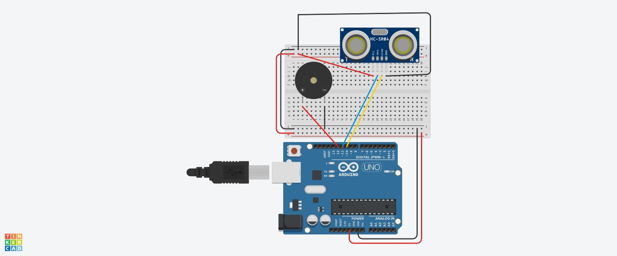

**Gerber File:**

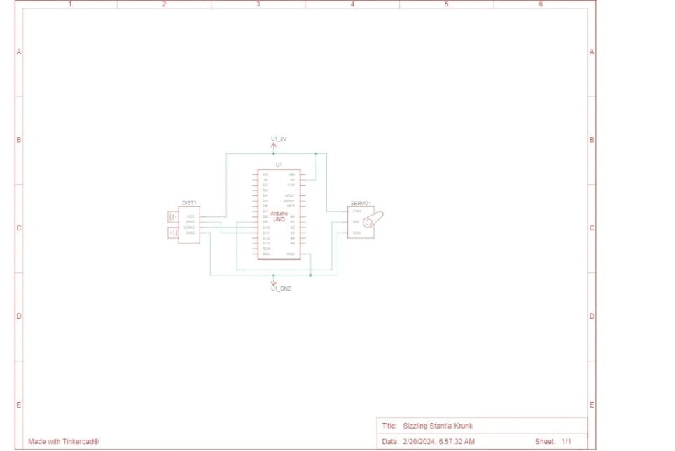

**Code for the solution:** **// C++ code**

**//**

**#define trigPin 11**

**#define echoPin 10**

**#define Buzzer 12**

**void setup() {**

**Serial.begin(9600);**

**pinMode(trigPin, OUTPUT);**

**pinMode(echoPin, INPUT);**

**pinMode(Buzzer, OUTPUT);**

**}**

**void loop() {**

**long duration, distance;**

**digitalWrite(trigPin, LOW);**

**delayMicroseconds(2);**

**digitalWrite(trigPin, HIGH);**

**delayMicroseconds(10);**

**digitalWrite(trigPin, LOW);**

**duration = pulseIn(echoPin, HIGH);**

**distance = duration * 0.0343 / 2;**

**// Print the distance to the Serial Monitor**

**Serial.print("Distance: ");**

**Serial.print(distance);**

**Serial.println(" cm");**

**delay(1000);**

**if(distance <= 10)**

**{**

**digitalWrite(Buzzer,HIGH);**

**}**

**else**

**{**

**digitalWrite(Buzzer,LOW);**

**}**

**}**